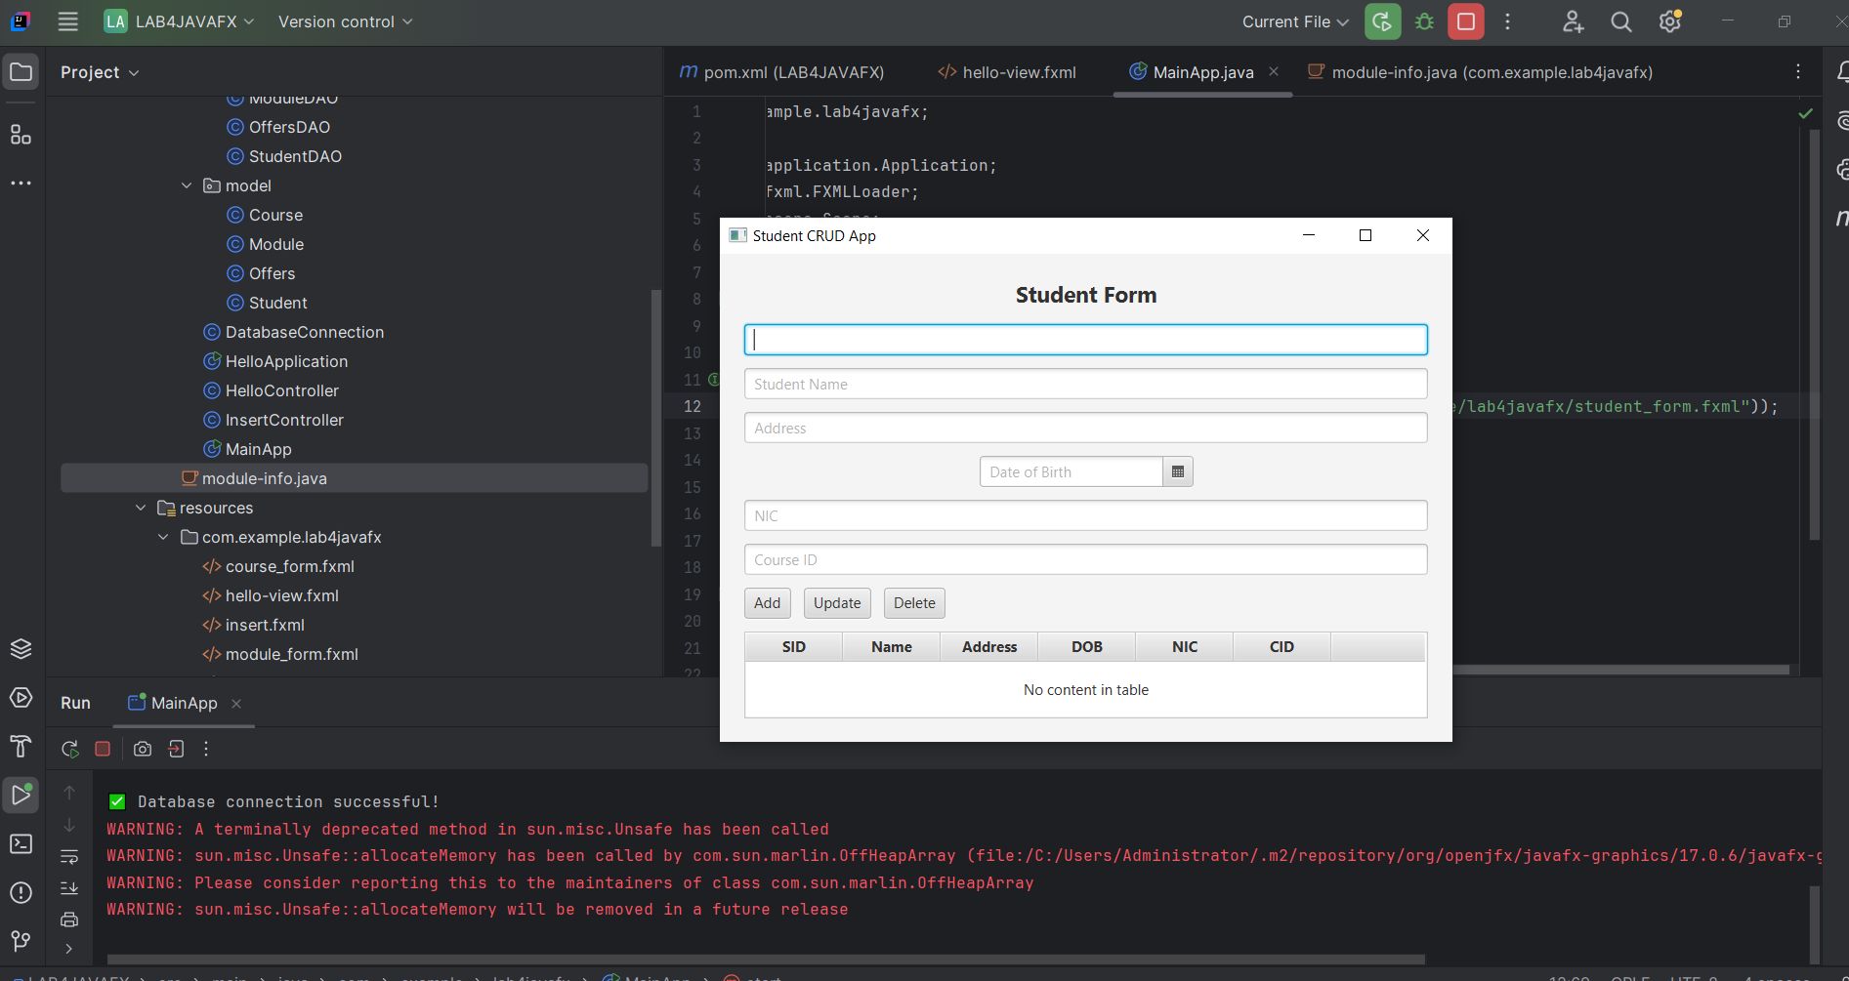

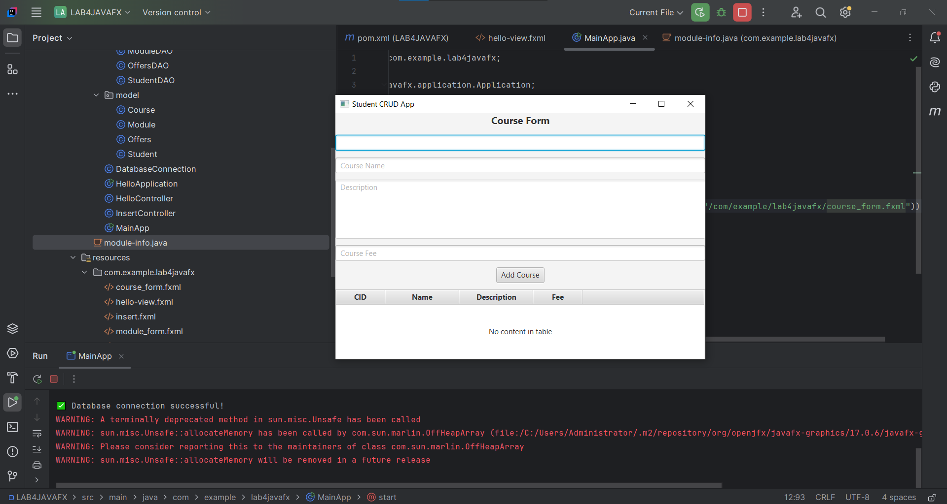

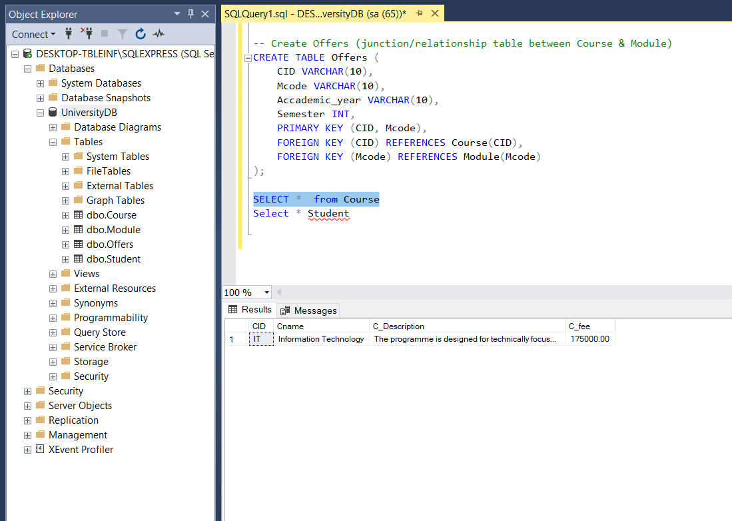

SQL FOR INSERTING TABLES

-- Create Course table

CREATE TABLE Course (

CID VARCHAR(10) PRIMARY KEY,

Cname VARCHAR(100) NOT NULL,

C_Description TEXT,

C_fee DECIMAL(10,2)

);

-- Create Student table

CREATE TABLE Student (

SID VARCHAR(15) PRIMARY KEY,

Sname VARCHAR(100) NOT NULL,

Address VARCHAR(255),

Dob DATE,

NIC VARCHAR(15) UNIQUE,

CID VARCHAR(10),

FOREIGN KEY (CID) REFERENCES Course(CID)

);

-- Create Module table

CREATE TABLE Module (

Mcode VARCHAR(10) PRIMARY KEY,

Mname VARCHAR(100) NOT NULL,

M_Description TEXT,

NoOfCredits INT

);

-- Create Offers (junction/relationship table between Course & Module)

CREATE TABLE Offers (

CID VARCHAR(10),

Mcode VARCHAR(10),

Accademic_year VARCHAR(10),

Semester INT,

PRIMARY KEY (CID, Mcode),

FOREIGN KEY (CID) REFERENCES Course(CID),

FOREIGN KEY (Mcode) REFERENCES Module(Mcode)

);

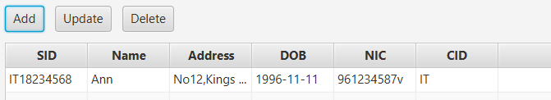

BEFORE UPDATE

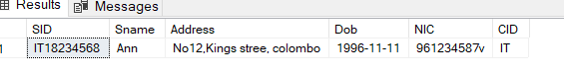

AFTER UPDATE

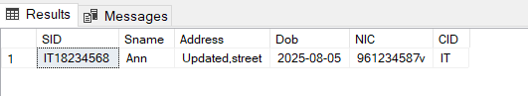

DELETED RECORD

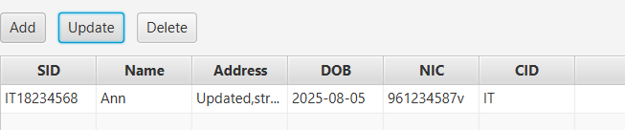

AFTER DELETE

